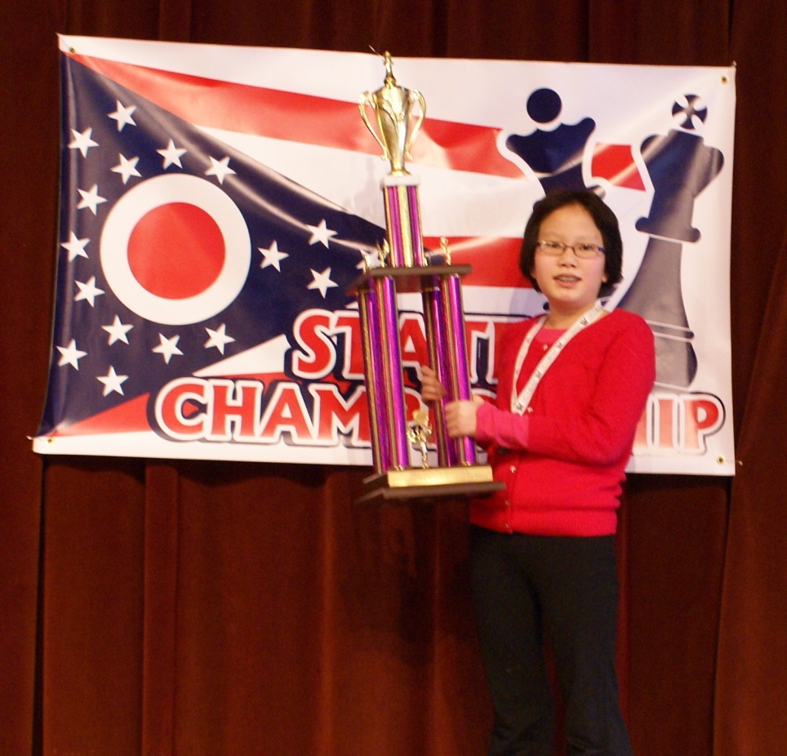

2013 State of Ohio All Girls Champion

Maggie Feng scores 5-0!

Top Team - North Canton Middle School

Organized by the Akron Chess Club in Cuyahoga Falls